CYCLE 4

PROGRAM 1

AIM

Write a program to print the fibanocci series using recursion.

SOURCECODE

num = int(input("How many numbers you need to print : "))
def fib(n):
if n <= 1:
return n
return fib(n-1) + fib(n-2)
for i in range(num):
print(fib(i), end = " ")

OUTPUT

PROGRAM 2

AIM

Write the program to implement a menu driven calculator.Use seperate functions for the different options.

SOURCECODE

def add(a, b):
return a + b

def subtract(a, b):
return a - b

def multiply(a, b):
return a * b

def divide(a, b):
if b == 0:
return "Cannot divide by zero."
return a / b

def display_menu():
print("Select operation: ")
print("1. Addition")
print("2. Subtraction")
print("3. Multiplication")
print("4. Division")
print("5. Exit")

while True:
display_menu()
choice = input("Enter choice : ")

if choice == '5':
print("Bye ... ")
break

num1 = float(input("Enter first number: "))
num2 = float(input("Enter second number: "))

if choice == '1':
result = add(num1, num2)
print(f"ans = {result}")
elif choice == '2':
result = subtract(num1, num2)
print(f"ans = {result}")
elif choice == '3':
result = multiply(num1, num2)
print(f"ans = {result}")
elif choice == '4':
result = divide(num1, num2)
print(f"ans = {result}")
else:
print("Invalid choice. Please try again.")

OUTPUT

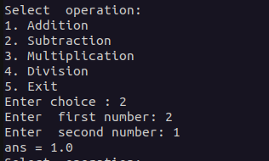
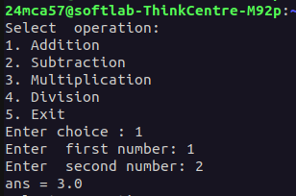
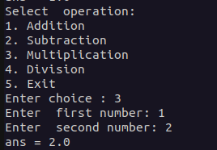
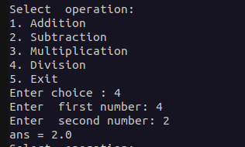

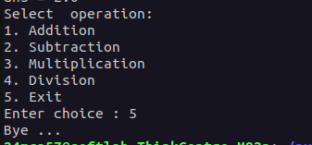

PROGRAM 3

AIM

Write a program to print the nth prime number.

SOURCECODE

def is_prime(n):
if n < 2:
return False
for i in range(2, n):
if n % i == 0:
return False
return True

num = 2
count = 0
n = int(input("Enter n: "))

while True:
if is_prime(num):
count += 1
if count == n:
print(f"{n}th prime number is: {num}")
break
num += 1

OUTPUT

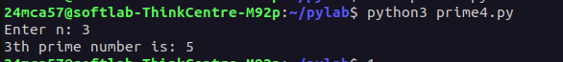

PROGRAM 4

AIM

Write a lamda functions to find area of squares,rectangle and triangle.

SOURCECODE

square = lambda side: side * side
rectangle = lambda length, width: length * width
triangle = lambda base, height: 0.5 * base * height

print("Square Area")
side = int(input("Enter the side of square : "))
print(square(side))
print("Rectangle Area")
length = int(input("Enter the length of rectangle : "))
width = int(input("Enter the width of rectangle : "))
print(rectangle(length, width))
print("Triangle Area")
base = int(input("Enter the base of triangle : "))
height = int(input("Enter the height of triangle : "))
print(triangle(base, height))

OUTPUT

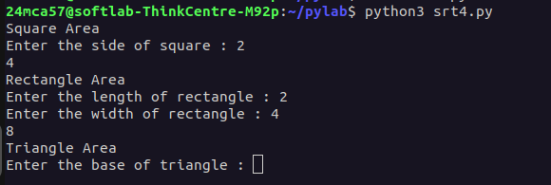

PROGRAM 5

AIM

Write a program to display powers of 2 using anonymous function

SOURCECODE

def powers_of_two(n):
numbers = range(n)
powers = map(lambda x: 2 ** x, numbers)
return list(powers)

n = int(input("Enter a number to display powers of 2 up to that power: "))

result = powers_of_two(n)
print(f"Powers of 2 from 0 to {n-1}: {result}")

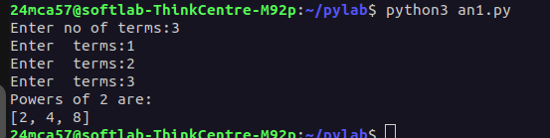
OUTPUT

PROGRAM 6

AIM

Write a program to display multiples of 3 using anonymous function[Hint use filter and lambda function].

SOURCECODE

t=int(input("Enter no of terms:"))
terms_lst=[]
for i in range(t):
terms=int(input("Enter terms:"))
terms_lst.append(terms)
multiplefnctn=filter(lambda x:x%3==0,terms_lst)
print("Multiples of 3 are:")
multiple_fnctn_list=list(multiplefnctn)
print(multiple_fnctn_list)

OUTPUT

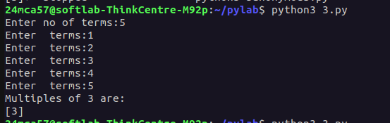

PROGRAM 7

AIM

Write a program to sum the series 1/1!+4/2!+27/3!+.......+nth terms.

SOURCECODE

ef factorial(n):
if n == 0:
return 1
else:
return n * factorial(n-1)

def sum_series(n):
sum = 0
for i in range(1, n + 1):
sum += (i ** i) / factorial(i)
return sum

n = int(input("Enter a Number: "))
print("Sum of the series:", sum_series(n))

OUTPUT

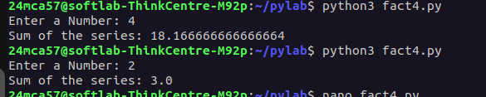

PROGRAM 8

AIM

Write a function called compare which take two strings s1 and s2 and integer n as arguments.The function should return n.True if the irst n characters of both the strings are same else the function should return false.

SOURCECODE

def compare(S1, S2, n):
return S1[:n] == S2[:n]

S1 = input("Enter First String: ")
S2 = input("Enter Second String: ")
n = int(input("Enter the position upto which the comparison should take place: "))
print("Comparison result:", compare(S1, S2, n))

OUTPUT

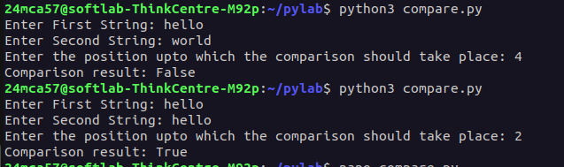

PROGRAM 9

AIM

Write a program to add variable length integer arguments passed to the function[also demo the use of docstrings]

SOURCECODE

def add_num(*args):
"""This function used as an example of variable length arguments"""
total=0
for num in args:
total+=num
return total
number_list=[]
n=int(input("Enter numbers in list:"))
for i in range(n):
num=int(input("Enter a number:"))
number_list.append(num)
result=add_num(*number_list)
print(f"Sum={result}")

OUTPUT

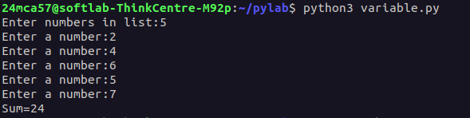

PROGRAM 10

AIM

Write a program using function to implement these formula for permutations and combination.The number of permutations of n objects takes data time isc(n-r)=/(r!*(n-r)!)

SOURCECODE

def factorial(n):
fact=1
for i in range(1,n+1):
fact*=i
return fact

def permutation(n,r):
return factorial(n)/factorial(n-r)
def combination(n,r):
return factorial(n)/(factorial(r)*factorial(n-r))

n=int(input("Enter value of n:"))
r=int(input("Enter value of r:"))
if n>=r>=0:
print(f"Number of permutations:p ({n},{r}):{permutation(n,r)}")
print(f"Number of combinations:c ({n},{r}):{combination(n,r)}")
else:
print("enter the correct value")

OUTPUT
